CLASS DIAGRAMS: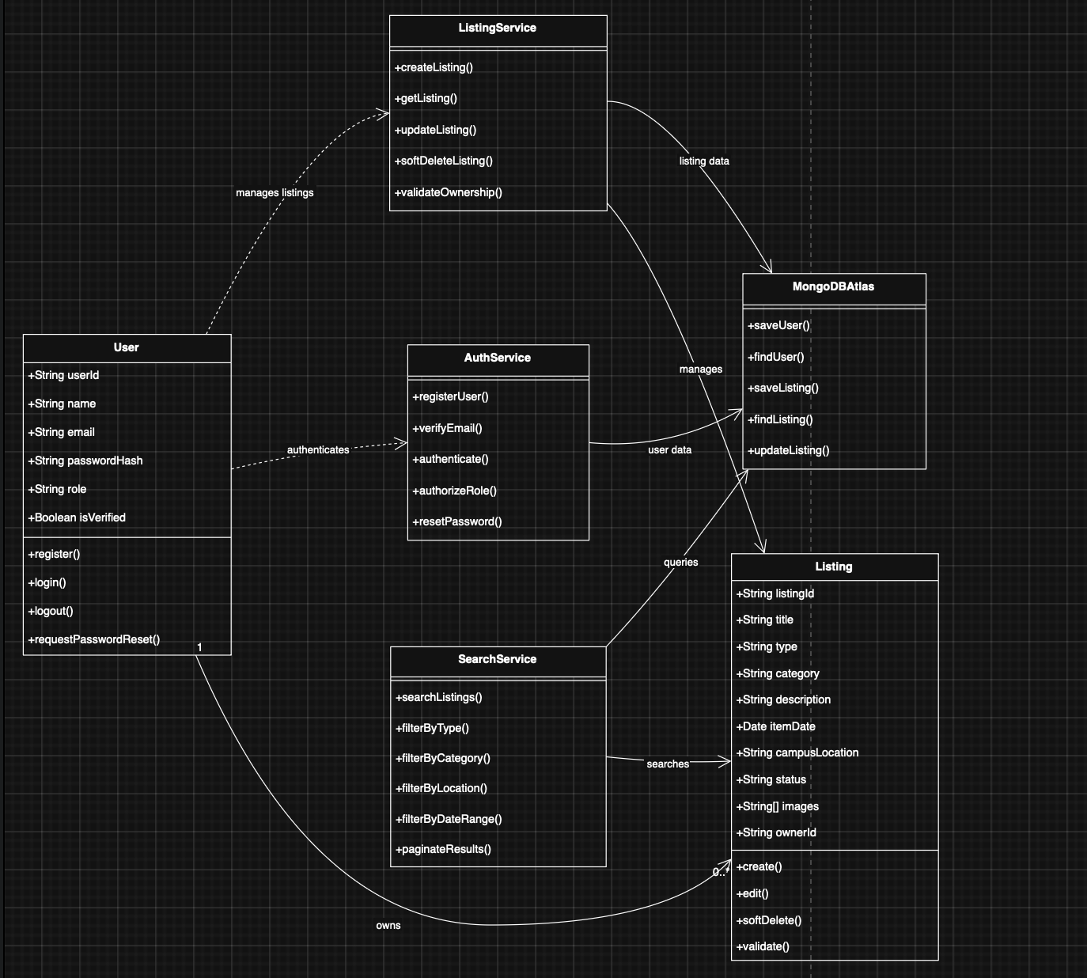
Class diagram for phase 1

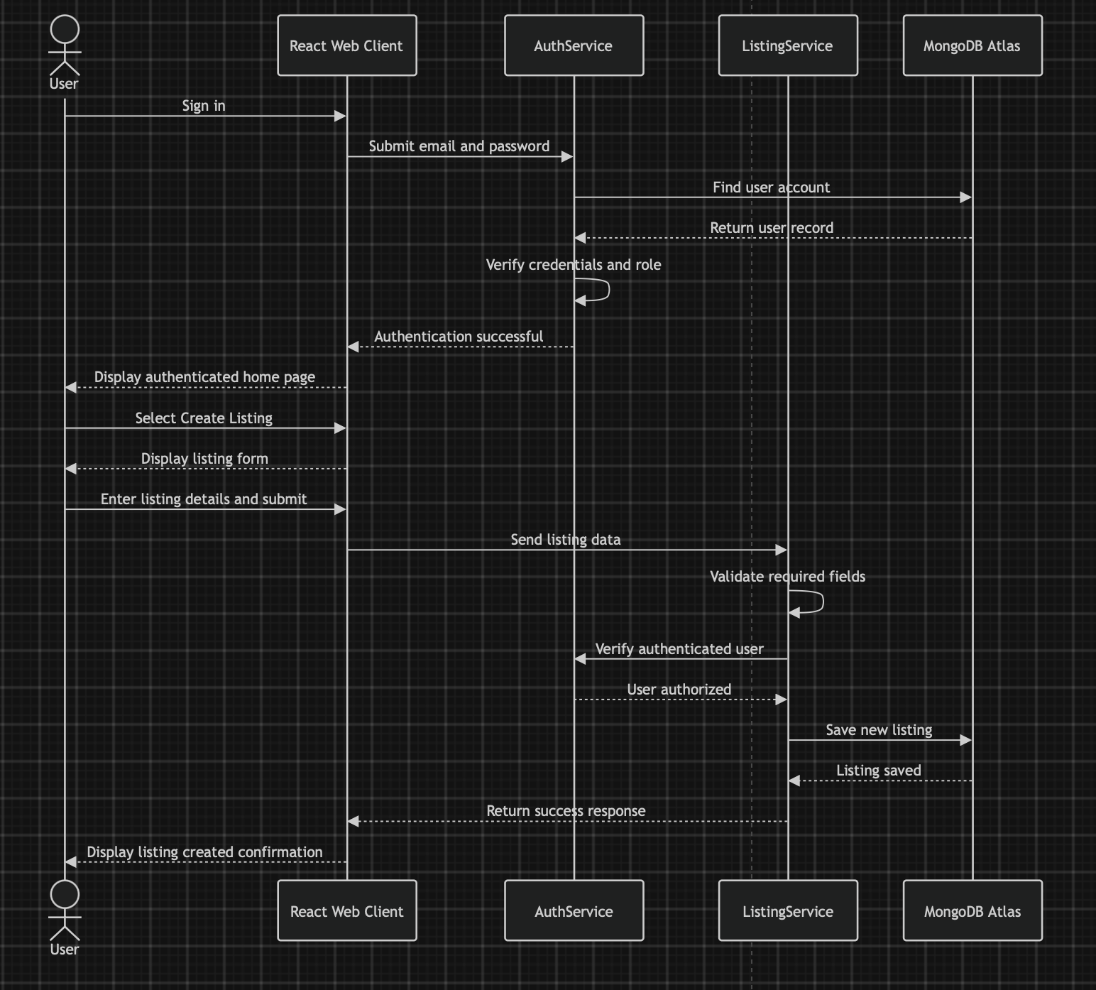Sequence diagram for phase 1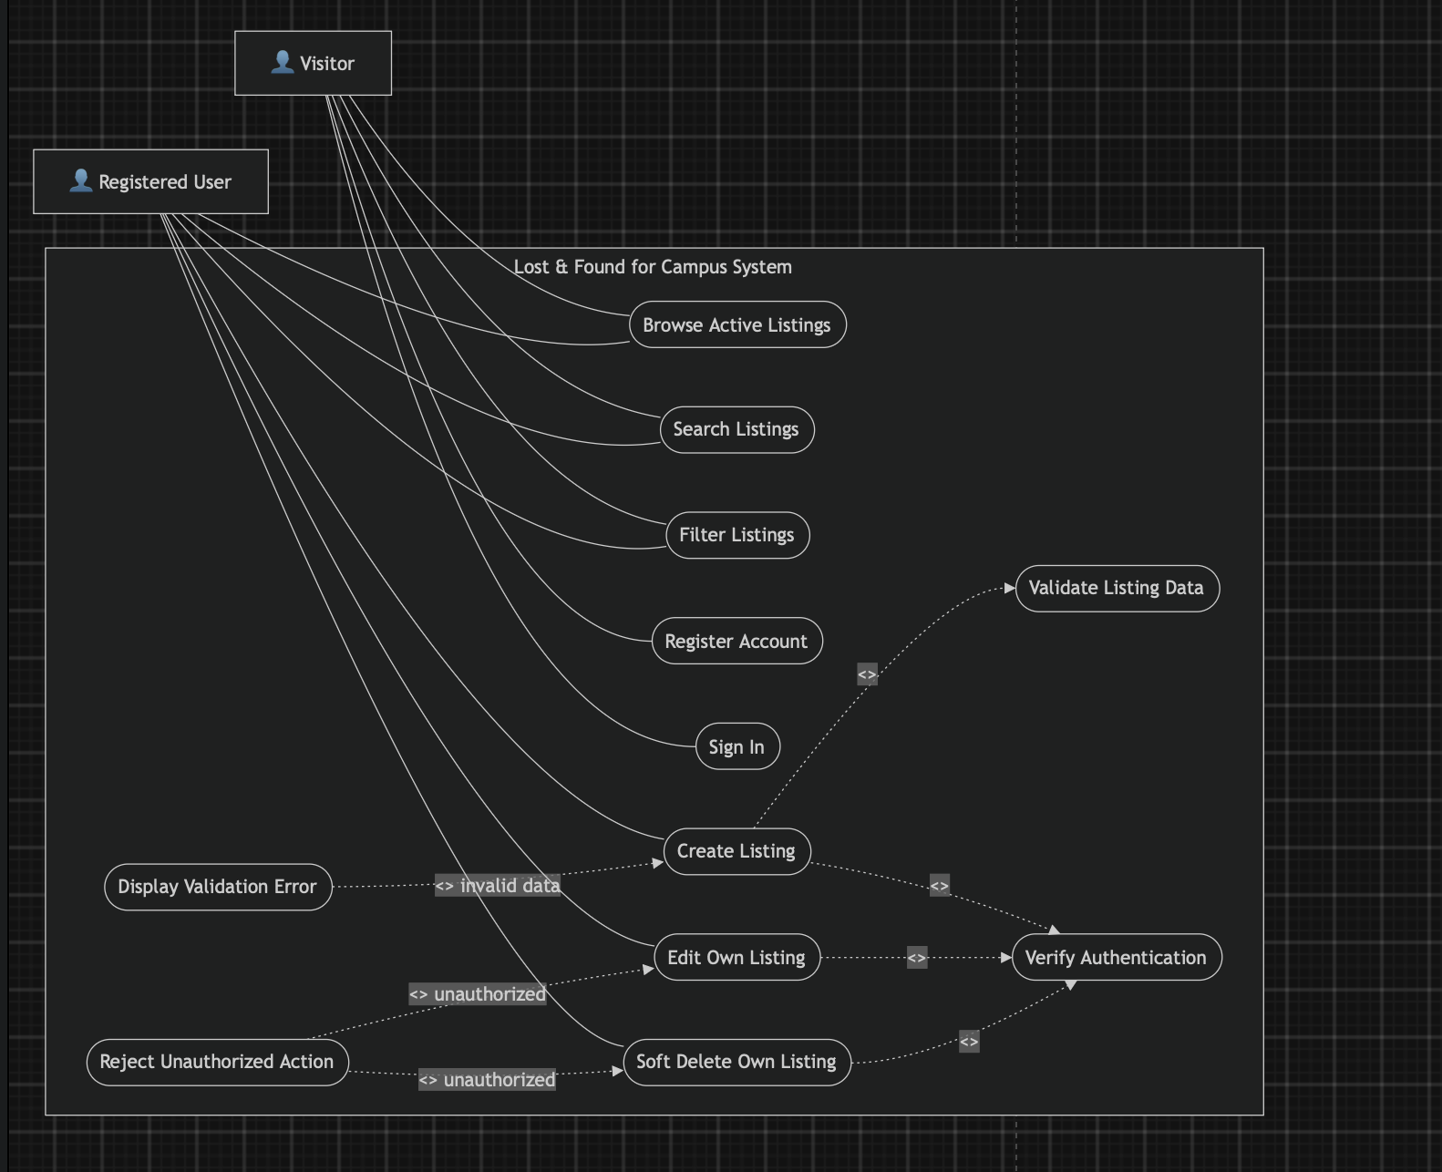
The Use Case Diagram shows how Visitors and Registered Users interact with the Lost & Found system.
In the valid flow, an authenticated user provides valid listing details, allowing the system to create or update the listing successfully.
In the invalid-data flow, missing or incorrect listing information triggers a validation error instead of completing the action.
In the unauthorized flow, the system rejects attempts to edit or delete another user’s listing, protecting listing ownership.

User Manual – Lost & Found for Campus

1. Purpose
The Lost & Found for Campus application provides a centralized platform where students and staff can report lost or found items and search existing listings. This Phase 1 manual covers account access, listing creation, browsing, searching, filtering, editing, and removing listings. Team Falcons - Deliverable 2

2. System Requirements
The application can be accessed through a supported web browser on a desktop, laptop, tablet, or mobile phone. No specialized hardware is required. Team Falcons - Deliverable 2

3. Registration and Login
Users register using a valid @my.unt.edu or @unt.edu email address. The email must be verified before the user can create a listing. Registered users can sign in, sign out, and request a password-reset link when necessary. Team Falcons - Deliverable 2
Screenshot: Insert Registration/Login page screenshot here.

4. Creating a Lost or Found Listing
After signing in, select Create Listing and choose whether the item is Lost or Found. Enter the title, category, description, date, campus building/zone, and item status. A Found listing requires at least one image, while an image is optional for a Lost listing. Submit the form after reviewing the entered information. Team Falcons - Deliverable 2
Screenshot: Insert Create Listing page screenshot here.

5. Browsing and Searching Listings
Users can browse active public listings and search using the title, description, category, brand, color, or keywords. Visitors do not need to sign in simply to browse or search public listings. Team Falcons - Deliverable 2
Screenshot: Insert Browse/Search page screenshot here.

6. Filtering Search Results
Search results can be filtered by Lost or Found type, category, campus building/zone, and date range. The application displays no more than 20 listings on a results page. Team Falcons - Deliverable 2
Screenshot: Insert Filter Results screenshot here.

7. Editing a Listing
A signed-in user can edit an Active listing that they own. Open the listing, select the edit option, make the required changes, and save the updated information. Ordinary users cannot modify another user's listing. Team Falcons - Deliverable 2
Screenshot: Insert Edit Listing screenshot here.

8. Removing a Listing
The owner can soft-delete their own Active listing when it is no longer required. The system prevents ordinary users from deleting listings owned by another user. Team Falcons - Deliverable 2

9. Error Handling
If information entered into a form is missing or invalid, the application identifies the affected field and displays a specific error message. If a user attempts an action they are not authorized to perform, the system rejects the request. Team Falcons - Deliverable 2

10. Phase 1 User Workflow
Register/Sign In → Browse or Search Listings → Create Lost/Found Listing → Edit Own Listing if Required → Soft Delete Own Listing if Required

